The Property Panel

The Property panel in Blender is a panel that is located on the right side of the application. It displays and edits both data and properties of either the active screen or object. This panel can be found directly below the Outliner.

This shows the properties that are available for the Cube. This will not be the first tab on the Property panel. This is the Object Property tab, which is represented by an orange square on the left side of the panel. As you can tell with this panel open that you are able to change a lot of the properties that are processed by this object.

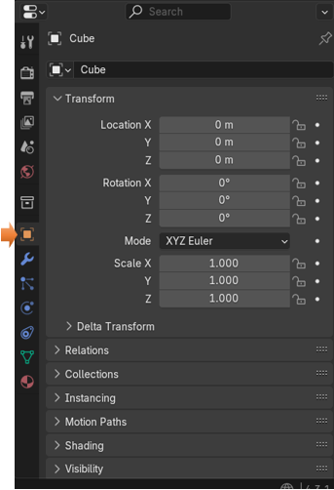

You can flip through the tabs, that reside on the left side of the panel. Each tab will represent a different category of properties for the elements in Blender.

For instance, besides being able to change dimensions or orientation, you will additionalyl find tabs where you can change the color. Changing the color of an object can be found in the Material Section of the Property panel. This is represented by a red ball tab, at the bottom of the panel.

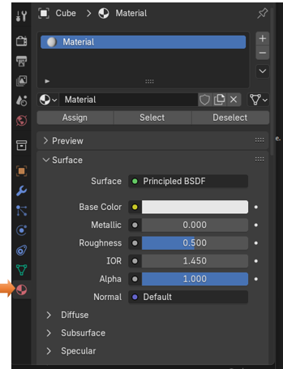

At the top of this panel, when you have a tool from the tool box selected, you will find options for this tool. This is the panel for the Loop Cut tool, which can be viewed by selecting the Loop cut tool from the toolbox in Edit mode.

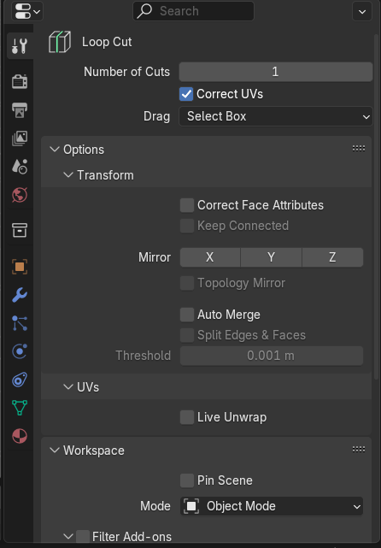

You will find panel for Modifiers, Physics, Particles and more. This is the Boolean Modifier in the Modifier tab

